Web app:

The app which is developed on web server and accessible via browser with internet

Webapp College web application

Module admin student emp dept these four are modules (EPICS)

Pages view std info register----------------user stories

View emp view timetable

Upload holidays view syllabus

View library upload post

View salary

|  |
| --- |
| Image section logs start of the page |
| Nav bar home about contact us login |
| Content section |
| Copy rights section |

For home navigation [home.html,home.compont.ts](http://home.html,home.compont.ts), home.sass

When you click the on home the content need to display on contection section

For About navigation about.html, about.componts.ts.about.sass

When you click on the about the content of about should be displayed in content section

For About navigation contactus.html, contactus.componts.ts, contactus.sass

When you click on the about the content of about should be displayed in content section

For About navigation login.html, login.componts.ts, login.sass

When you click on the about the content of about should be displayed in content section



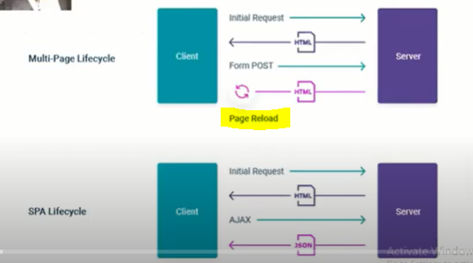



Angular

Module 1 moduel2 module3



Componet1 Componet1



Componet2 componet2



Component 3 component3

Where to write the single page code is index.html

<!doctype html>

<html lang="en">

<head>



<meta charset="utf-8">

<title>SPAAPP</title>

<base href="/">

<meta name="viewport" content="width=device-width, initial-scale=1">

<link rel="icon" type="image/x-icon" href="favicon.ico">

</head>

<body>

<app-root></app-root>



</body>

</html>

we have to devide this body into 4 parts

1)image section

2)navbar section

3)content section

This section data will change clicked on the navigation menu bar home, about, contactus, login do this in this section we have to keep<app-root><app-root>

4) copyright section